Ex. No. : 01C Date: 23.01.2026
Register No.: 231701046 Name: Sam Sundar

BMI Calculator
Aim:
Create an app that calculates the Body Mass Index (BMI) based on user input for weight and height in EditText fields. The result is displayed in a TextView after pressing a Button.

Procedure:

- Create a New Android Project
- Open Android Studio.
- Click New Project → Empty Activity.
- Enter the application name as Experiment3_MADD_46.
- Select Kotlin as the programming language.
- Click Finish.
- Configure AndroidManifest.xml
- Open AndroidManifest.xml.
- Declare MainActivity inside the <application> tag.
- Add MAIN action and LAUNCHER category to make it the startup activity.
- Apply the required theme for the application.
- Design the User Interface
- Open activity_main.xml.
- Use a LinearLayout with vertical orientation and padding.
- Add two EditText fields:
  - One for Weight (kg)
  - One for Height (cm)
- Set input type to numeric for both fields.
- Add a Button labeled Calculate BMI.
- Add a TextView to display the BMI result and status.
- Implement Kotlin Logic
- Open MainActivity.kt.
- Load the layout using setContentView().
- Access UI elements using findViewById().
- Set an OnClickListener for the Calculate BMI button.
- Validate user input to ensure fields are not empty.
- Convert height from centimeters to meters.
- Calculate BMI using the formula:
$$\text{BMI}=\frac{\text{Weight (kg)}}{{\text{Height (m)}}^{2}}$$
- Determine BMI category (Underweight, Normal, Overweight, Obese).
- Display the BMI value and category in the TextView.
- Run the Application
- Connect an Android emulator or physical device.
- Click Run ▶ in Android Studio.
- Launch the application.
- Verify the Output
- Enter weight and height values.
- Click Calculate BMI.
- The BMI value and health status are displayed on the screen.
- If inputs are empty, an error message is shown.

AndroidManifest.xml

<?xml version="1.0" encoding="utf-8"?>
<manifest xmlns:android="http://schemas.android.com/apk/res/android"
xmlns:tools="http://schemas.android.com/tools">
<application
android:allowBackup="true"
android:dataExtractionRules="@xml/data_extraction_rules"
android:fullBackupContent="@xml/backup_rules"
android:icon="@mipmap/ic_launcher"
android:label="@string/app_name"
android:roundIcon="@mipmap/ic_launcher_round"
android:supportsRtl="true"
android:theme="@style/Theme.Experiment3_MADD_46">
<activity
android:name=".MainActivity"
android:exported="true">
<intent-filter>
<action android:name="android.intent.action.MAIN" />
<category android:name="android.intent.category.LAUNCHER" />
</intent-filter>
</activity>
</application>
</manifest>

Activity_main.xml

<?xml version="1.0" encoding="utf-8"?>
<LinearLayout xmlns:android="http://schemas.android.com/apk/res/android"
android:layout_width="match_parent"
android:layout_height="match_parent"
android:orientation="vertical"
android:padding="24dp">
<EditText
android:id="@+id/etWeight"
android:layout_width="match_parent"
android:layout_height="wrap_content"
android:hint="Weight (kg)"
android:inputType="numberDecimal"/>
<EditText
android:id="@+id/etHeight"
android:layout_width="match_parent"
android:layout_height="wrap_content"
android:hint="Height (cm)"
android:inputType="numberDecimal"
android:layout_marginTop="12dp"/>
<Button
android:id="@+id/btnCalc"
android:layout_width="match_parent"
android:layout_height="wrap_content"
android:text="Calculate BMI"
android:layout_marginTop="16dp"/>
<TextView
android:id="@+id/tvResult"
android:layout_width="match_parent"
android:layout_height="wrap_content"
android:textSize="18sp"
android:layout_marginTop="16dp"/>
</LinearLayout>

MainActivity.kt

package com.example.experiment_3_madd_46
import android.os.Bundle
import android.widget.Button
import android.widget.EditText
import android.widget.TextView
import androidx.appcompat.app.AppCompatActivity
class MainActivity : AppCompatActivity() {
override fun onCreate(savedInstanceState: Bundle?) {
super.onCreate(savedInstanceState)
setContentView(R.layout.activity_main)
val etWeight = findViewById<EditText>(R.id.etWeight)
val etHeight = findViewById<EditText>(R.id.etHeight)
val tvResult = findViewById<TextView>(R.id.tvResult)
val btnCalc = findViewById<Button>(R.id.btnCalc)
btnCalc.setOnClickListener {
if (etWeight.text.isEmpty() || etHeight.text.isEmpty()) {
tvResult.text = "Please enter all values"
return@setOnClickListener
}
val weight = etWeight.text.toString().toFloat()
val heightCm = etHeight.text.toString().toFloat()
val heightM = heightCm / 100
val bmi = weight / (heightM * heightM)
val status = when {
bmi < 18.5 -> "Underweight"
bmi < 25 -> "Normal"
bmi < 30 -> "Overweight"
else -> "Obese"
}
tvResult.text = "BMI: %.2f (%s)".format(bmi, status)
}
}
}

Output:

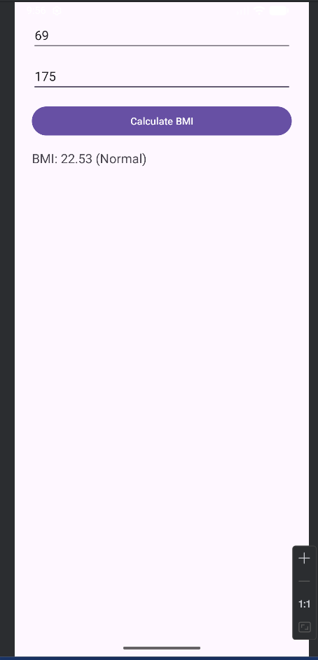

Result:
The Android application was successfully developed to calculate Body Mass Index (BMI) and display the corresponding health status based on user input.

